Test Results:

Group 1: Test the sample file provided in the package("test.json")

Query 1: $.routes[0].steps[1].loc.lat

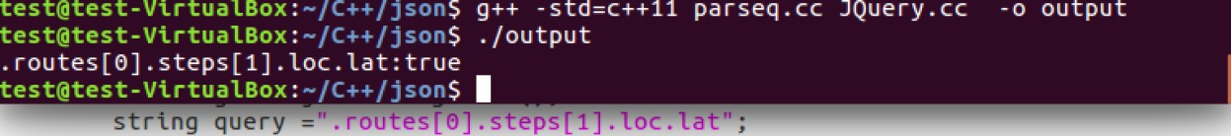

Query 2: $.routes[0].steps[0:1].dis.text

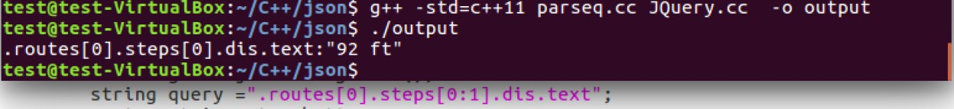

Query 3: $.routes[*].steps[0].dis.text

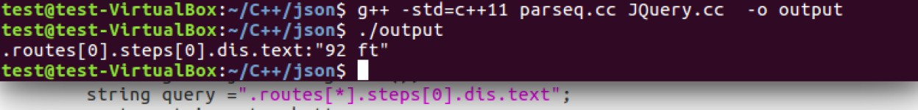

Query 4: $.routes[0]..loc.lat

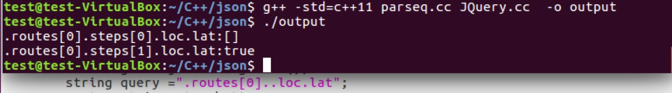

Query 5: $..lat

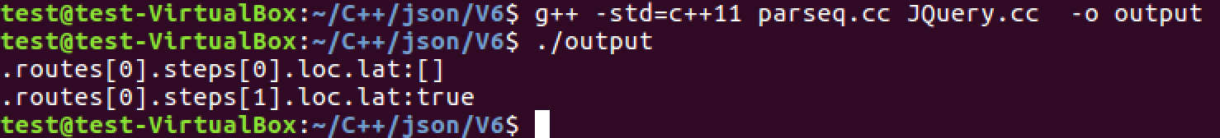

Query 6: $..routes[*]..loc

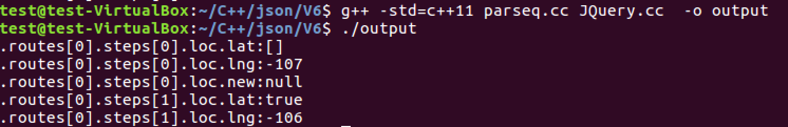Group 2: Test "random.json"

Query 1: $.root[0].friends[0].id

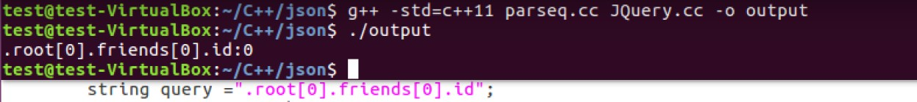

Query 2: $.root..name

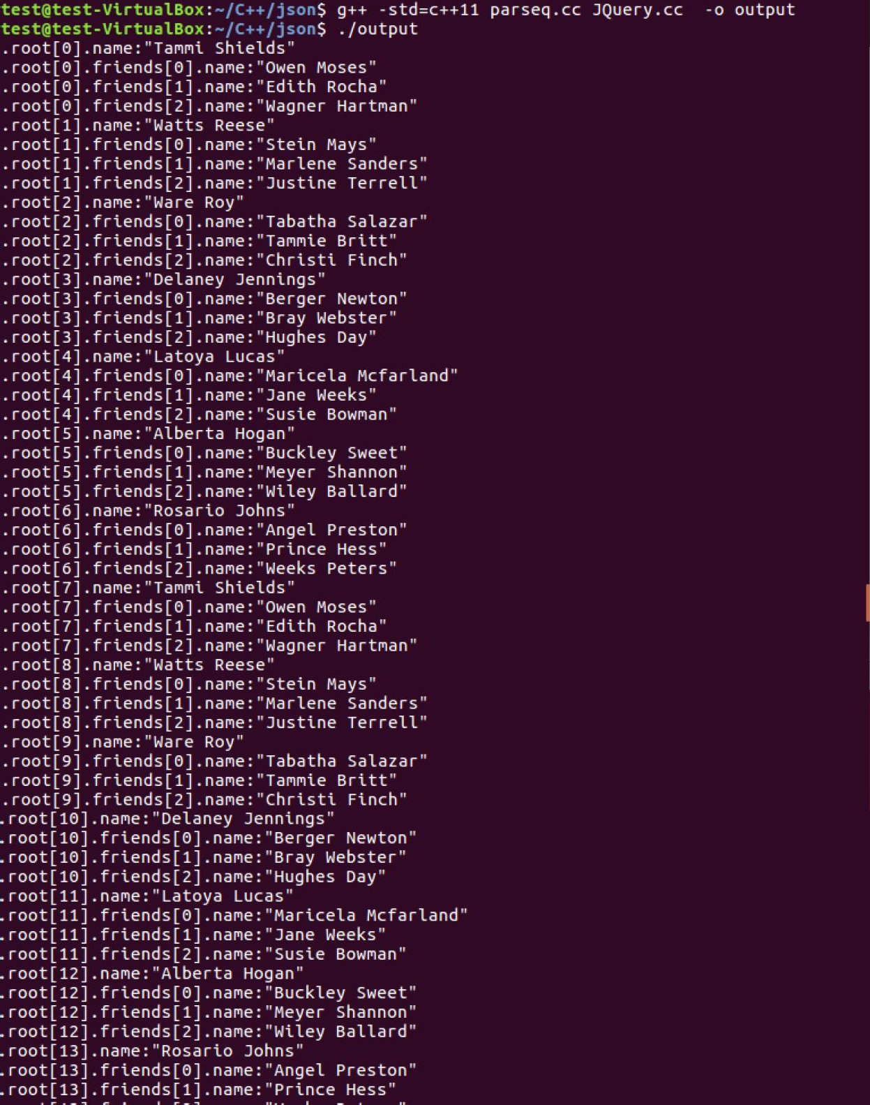

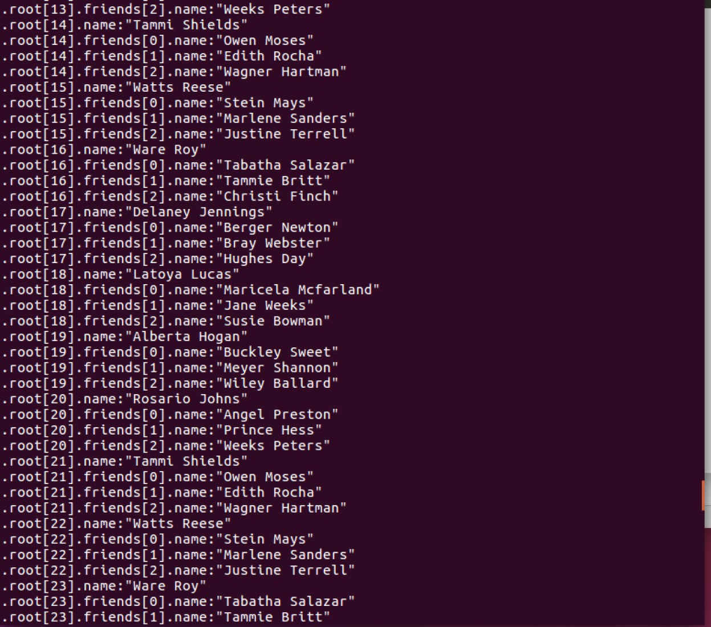

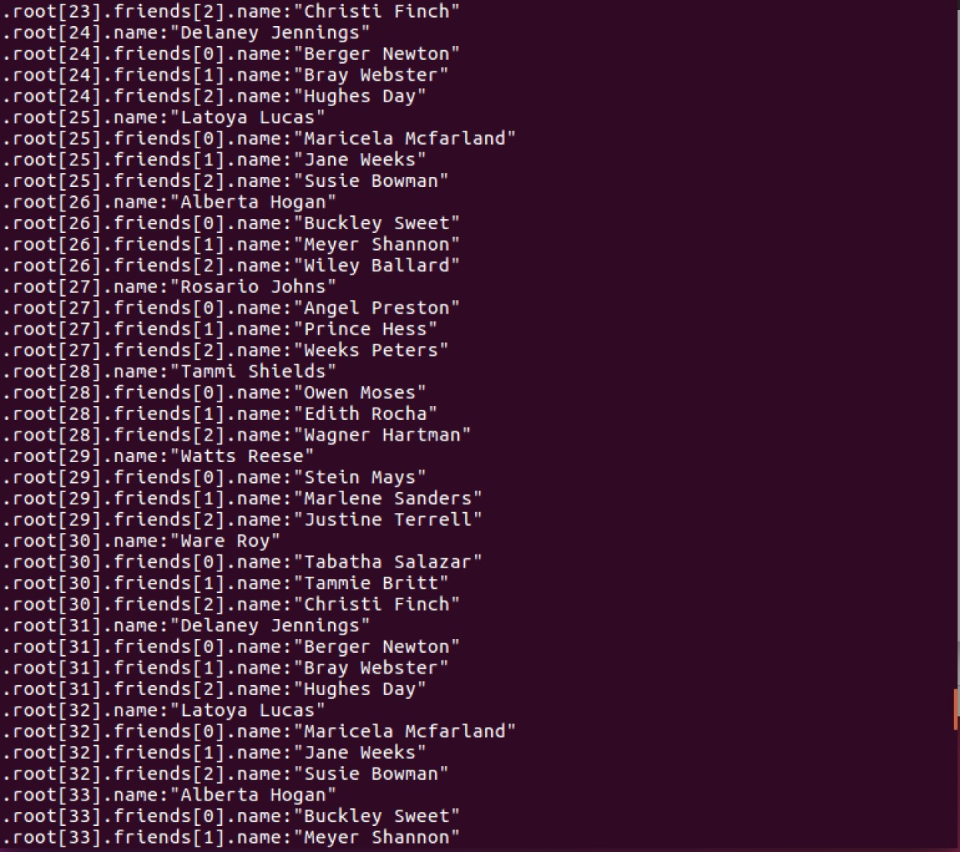

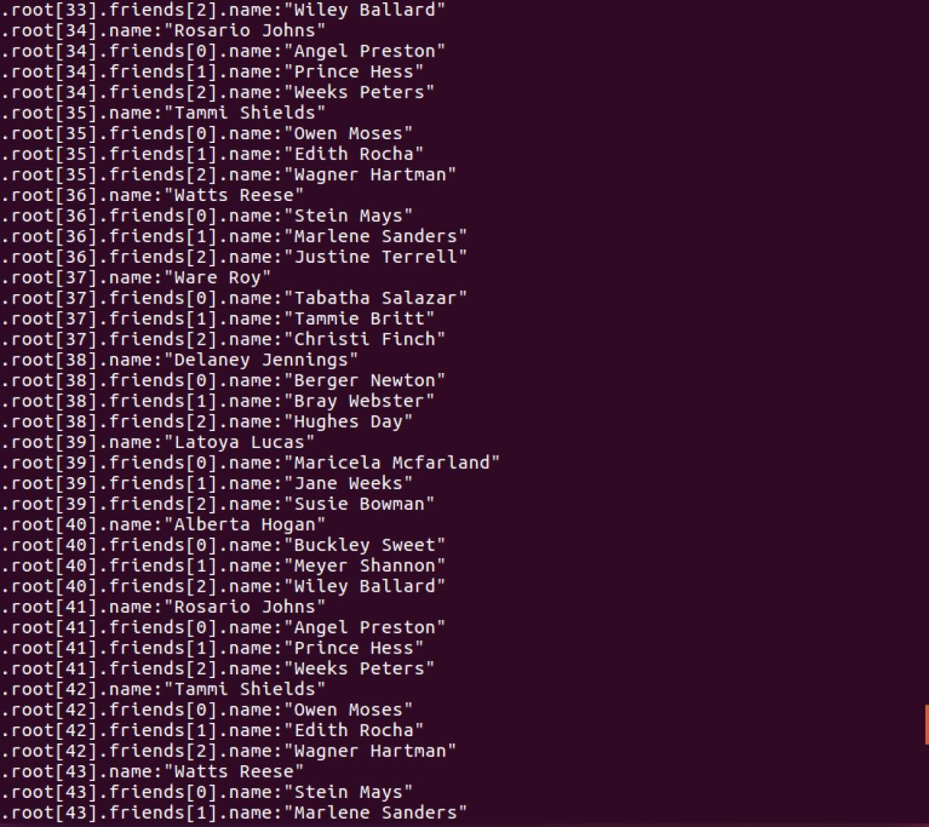

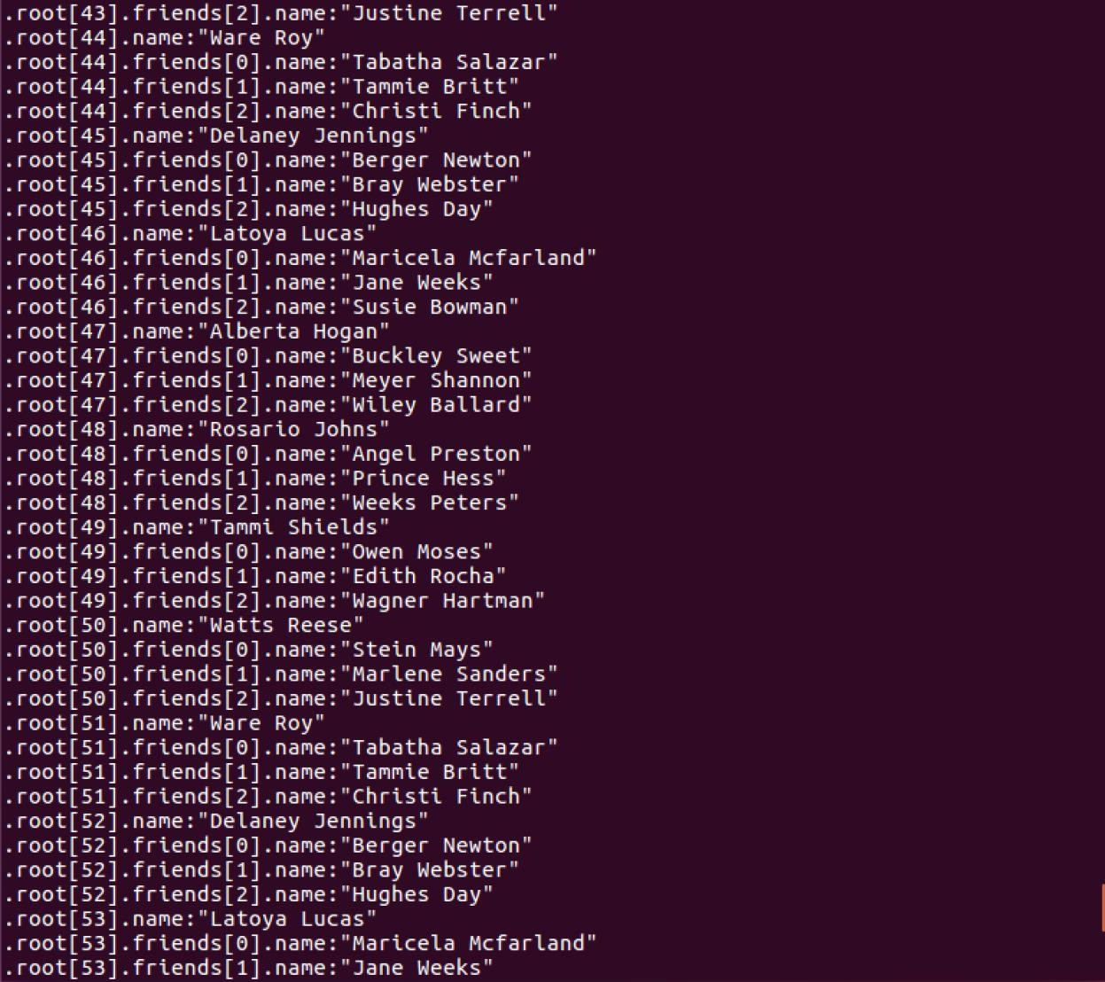

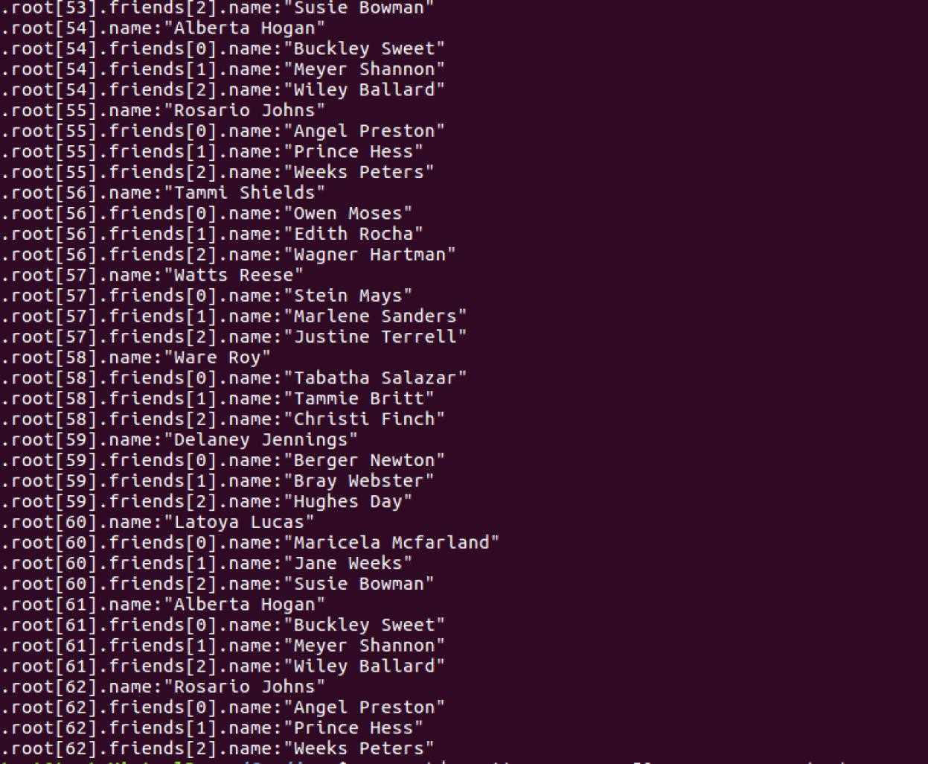

Query 3: $.root[2:5].tags

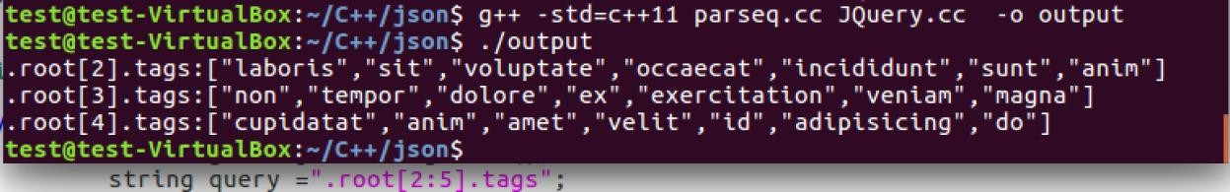

Query 4: $.root[*]..id

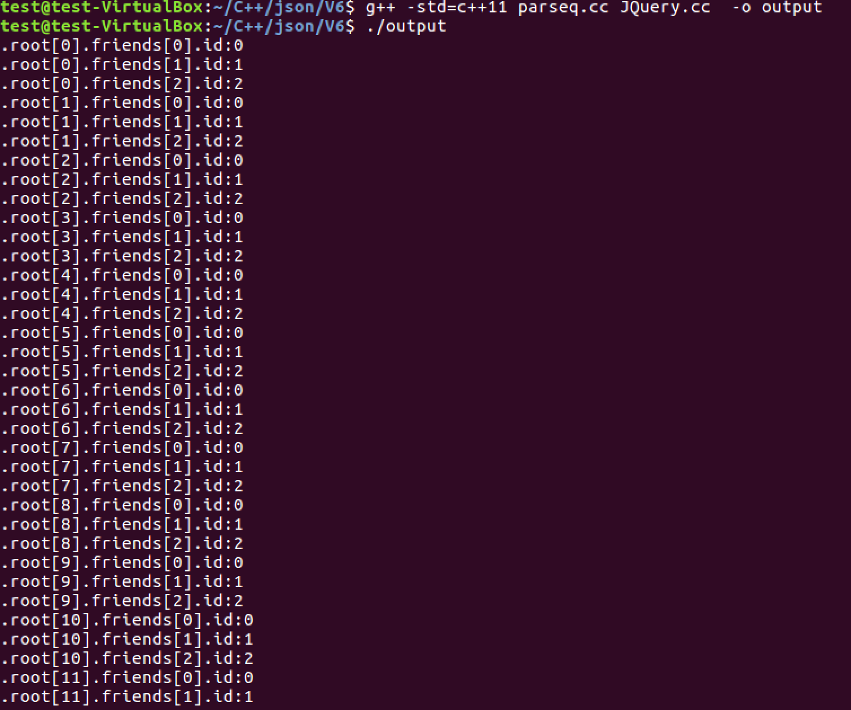

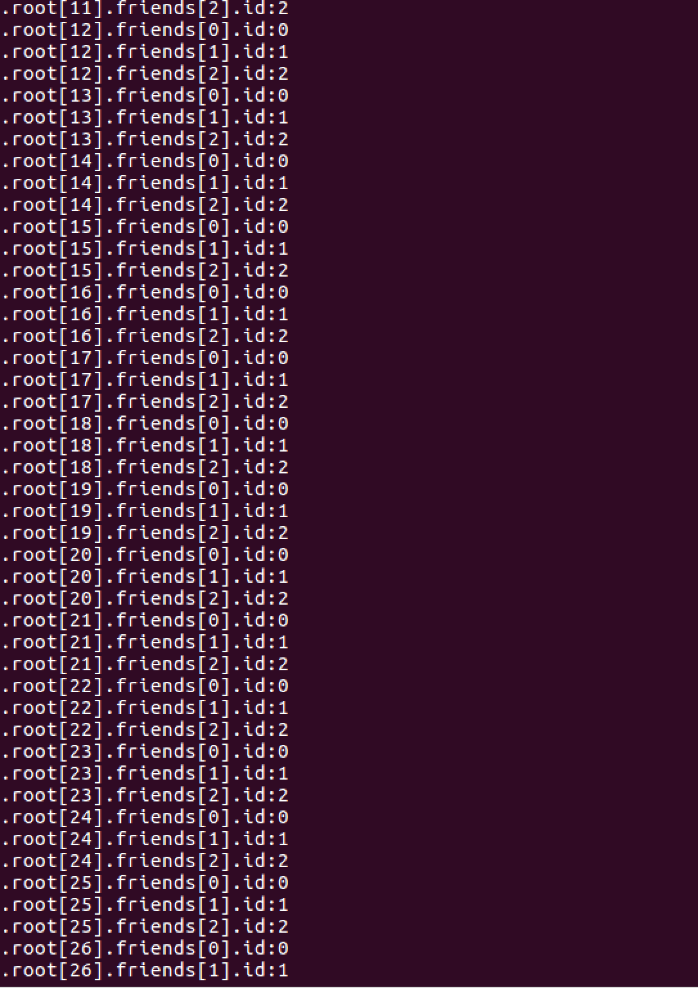

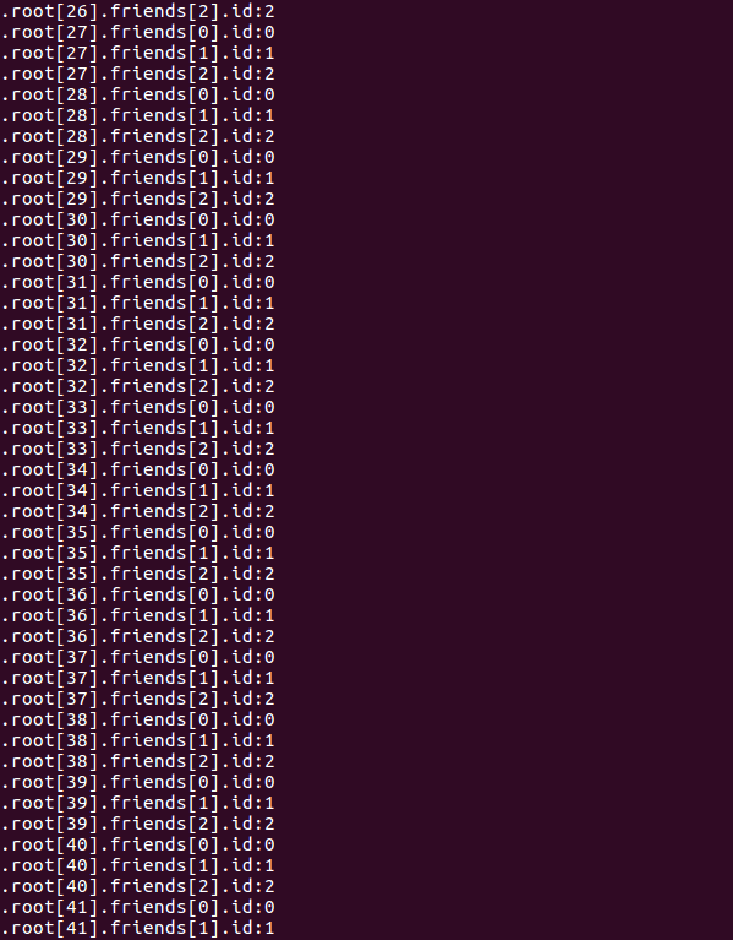

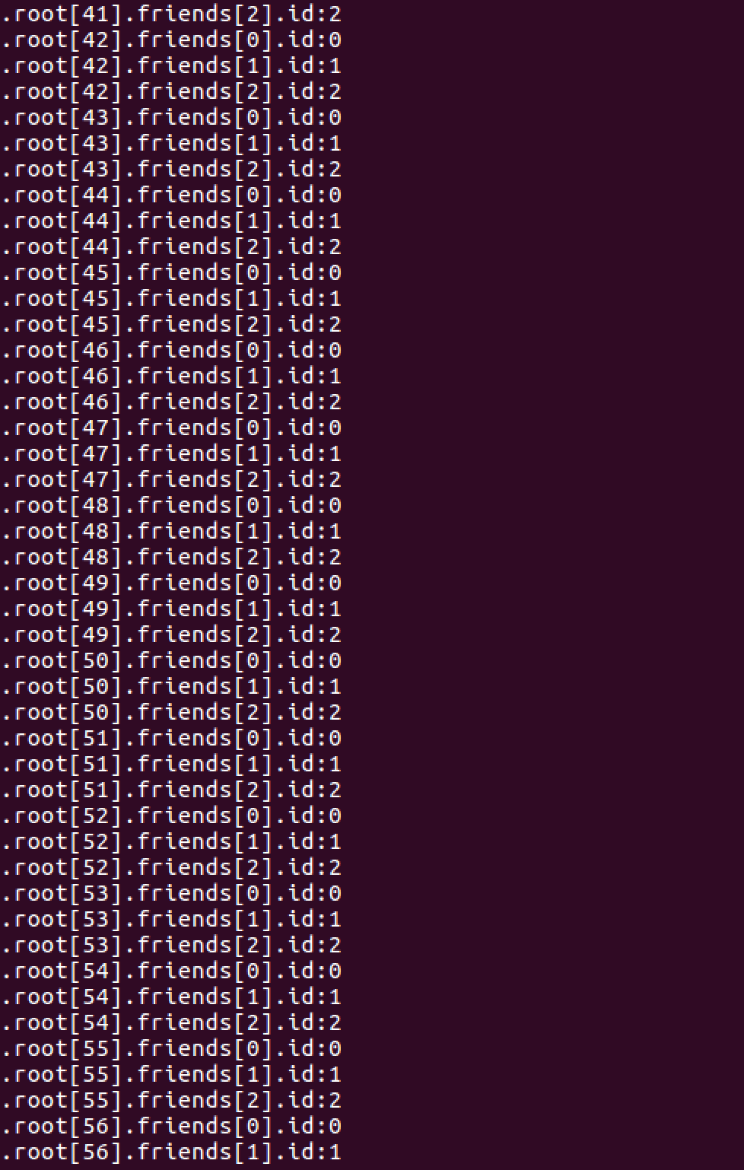

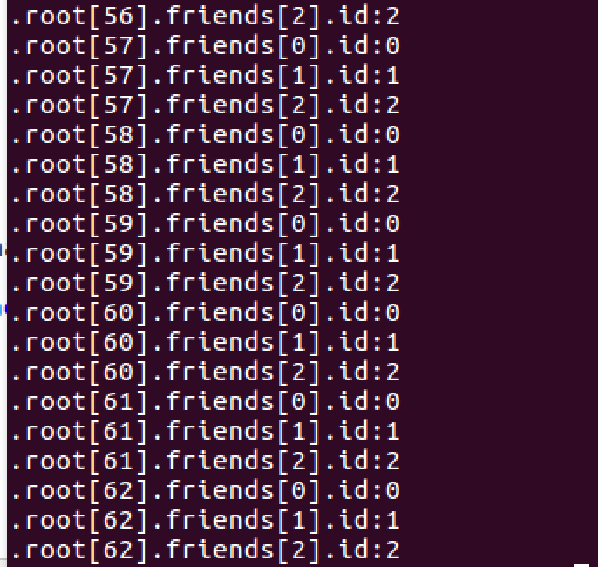

Group 3: Test "twitter.json"

Query 1: $.root[0].contributors

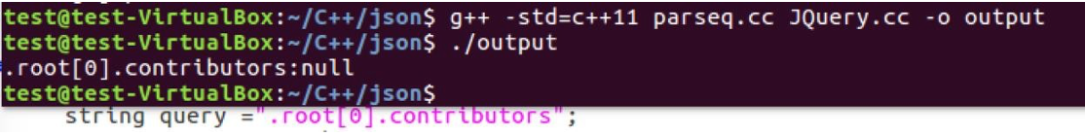

Query 2: $.root[*].quoted_status.entities.user_mentions[*].id

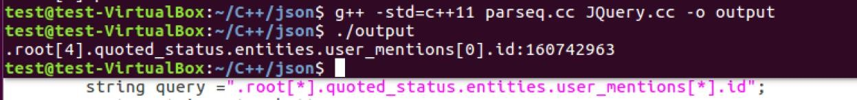

Query 3: $.root[0].entities.hashtags[0]..indices

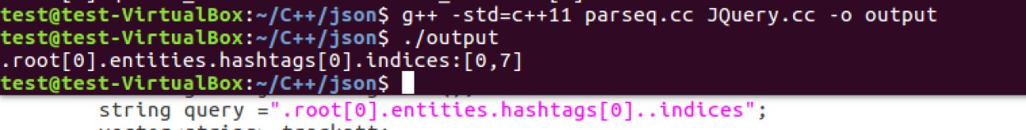

Query 4: $.root[3:5].place

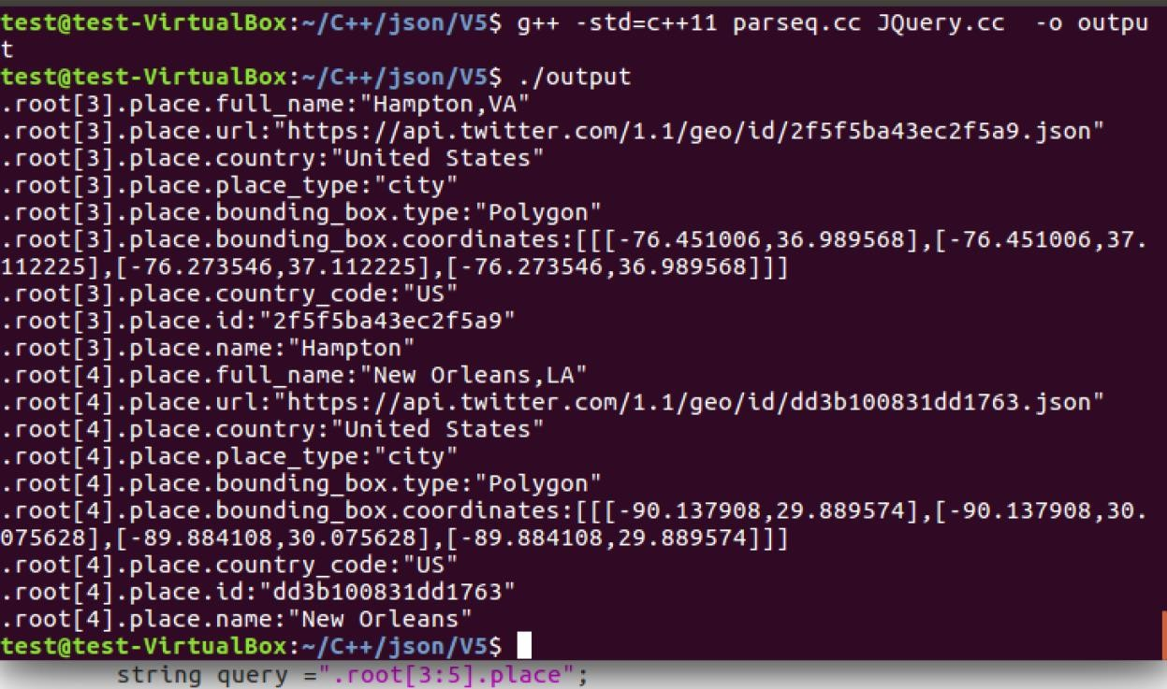

Query 5: $..place

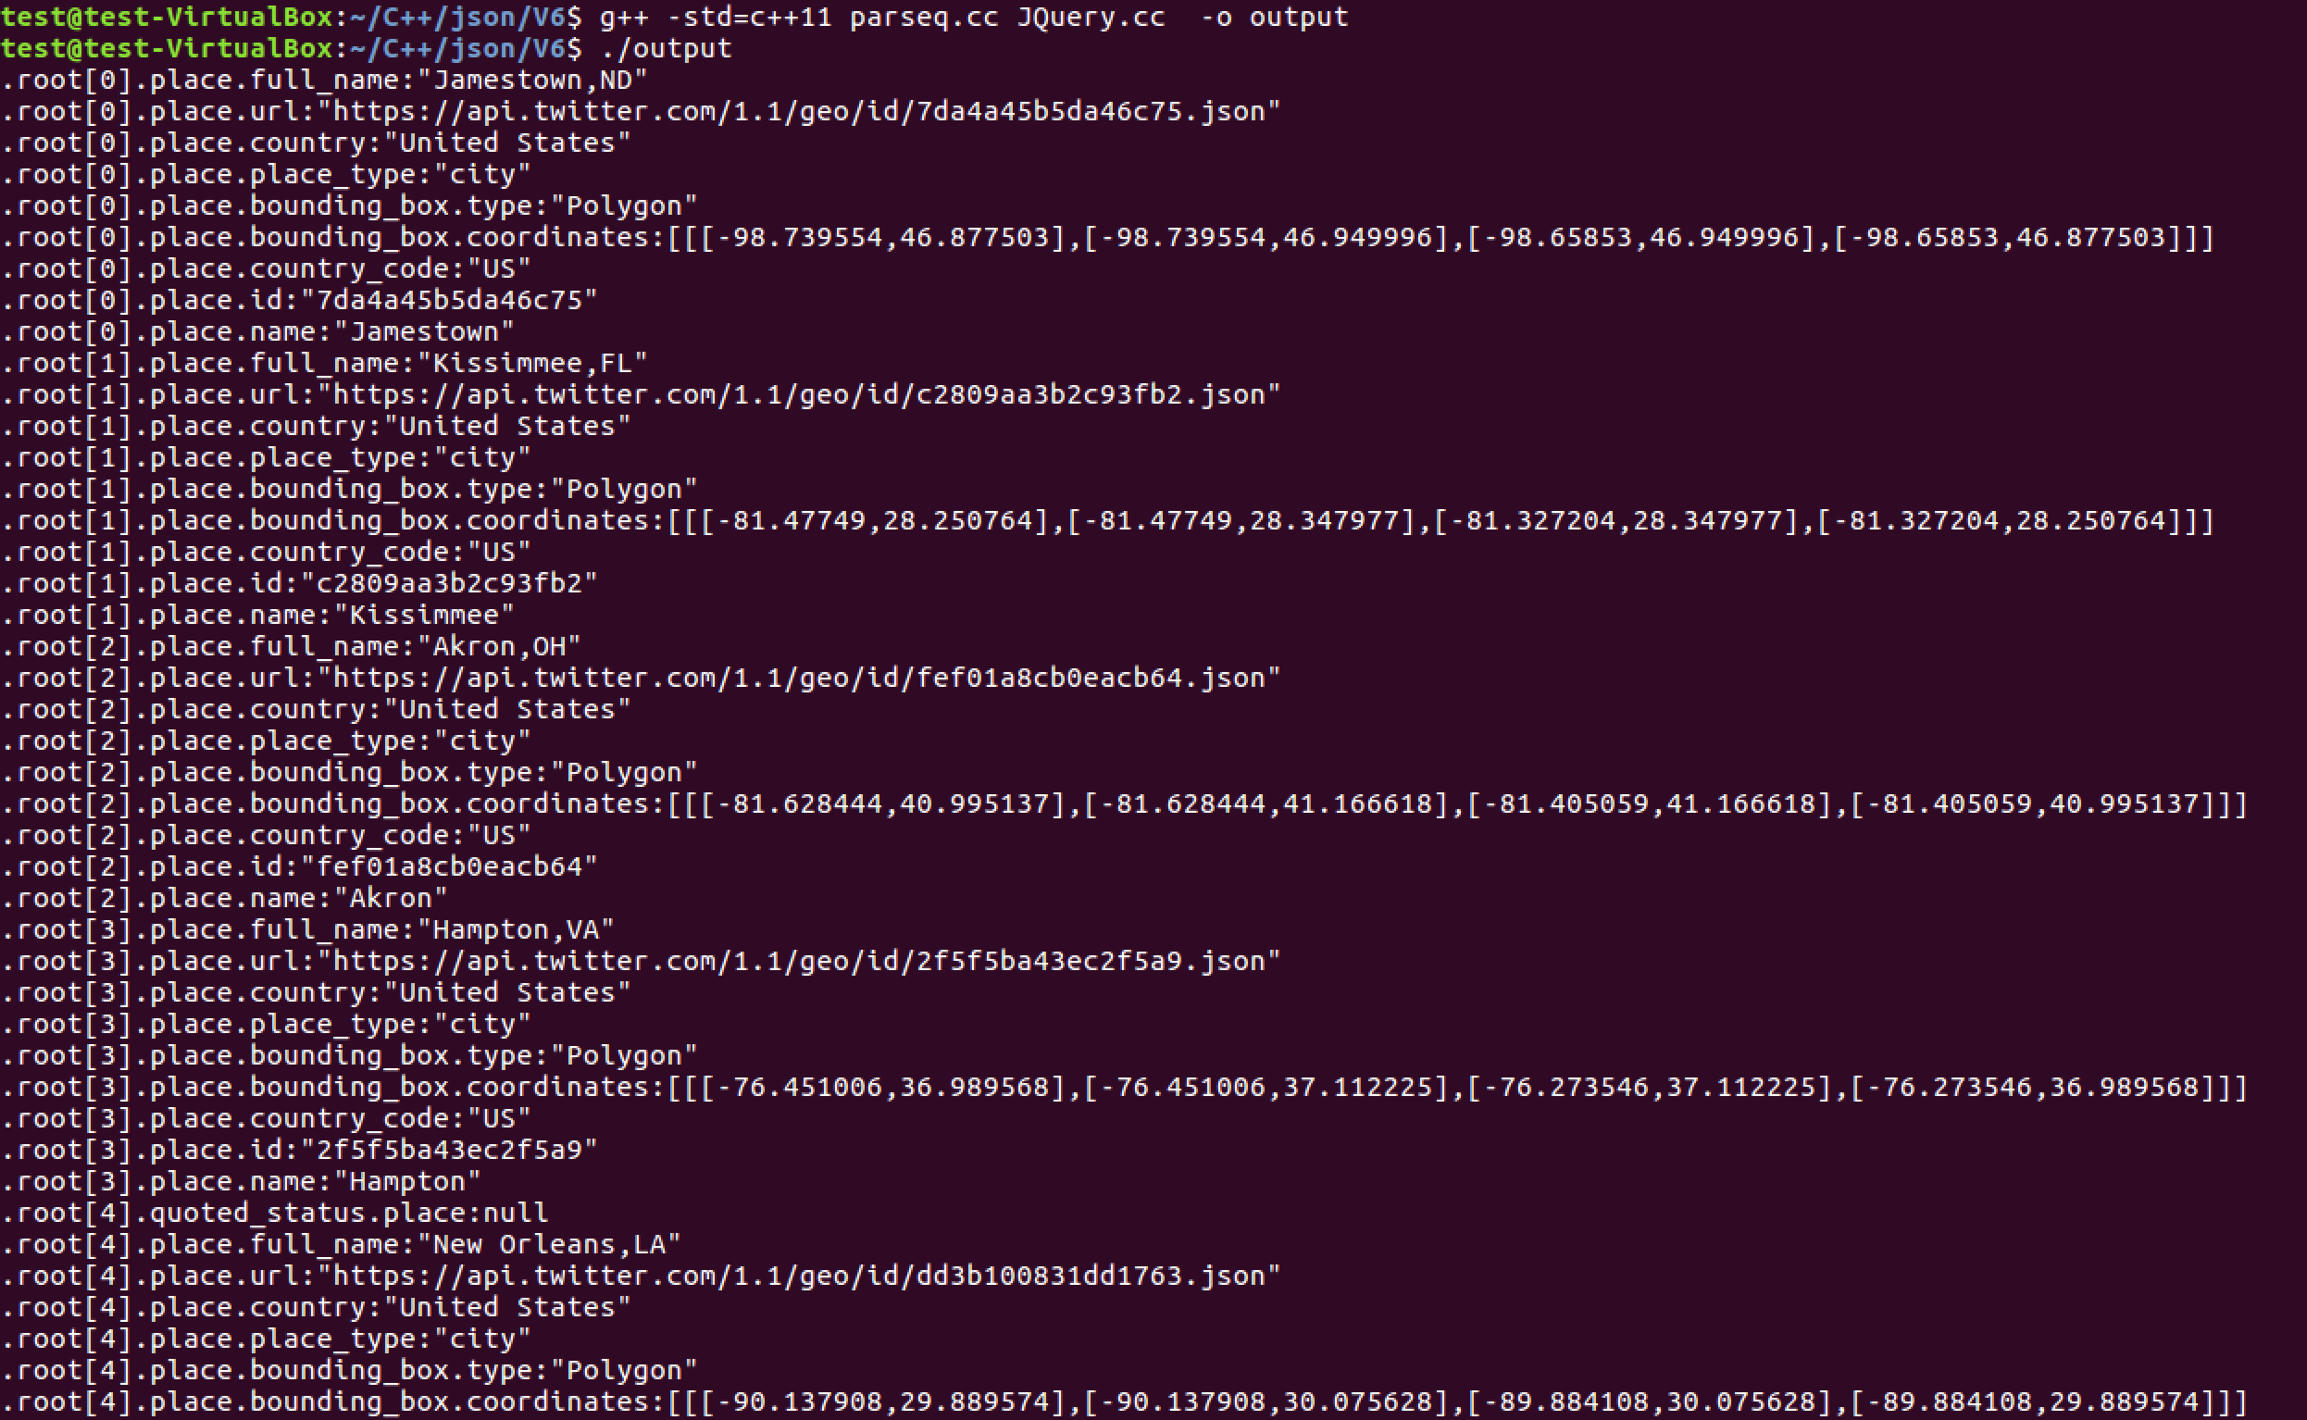

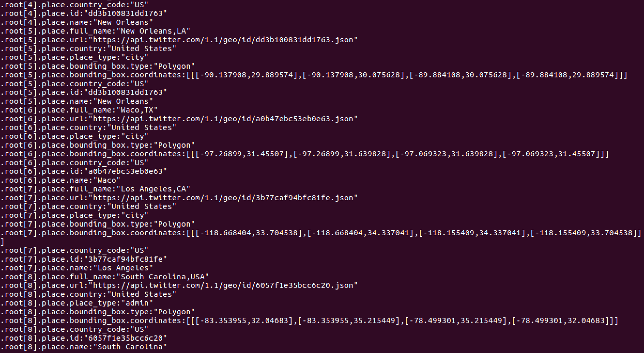

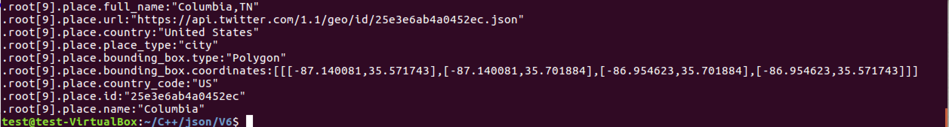

Query 6: $.root..id

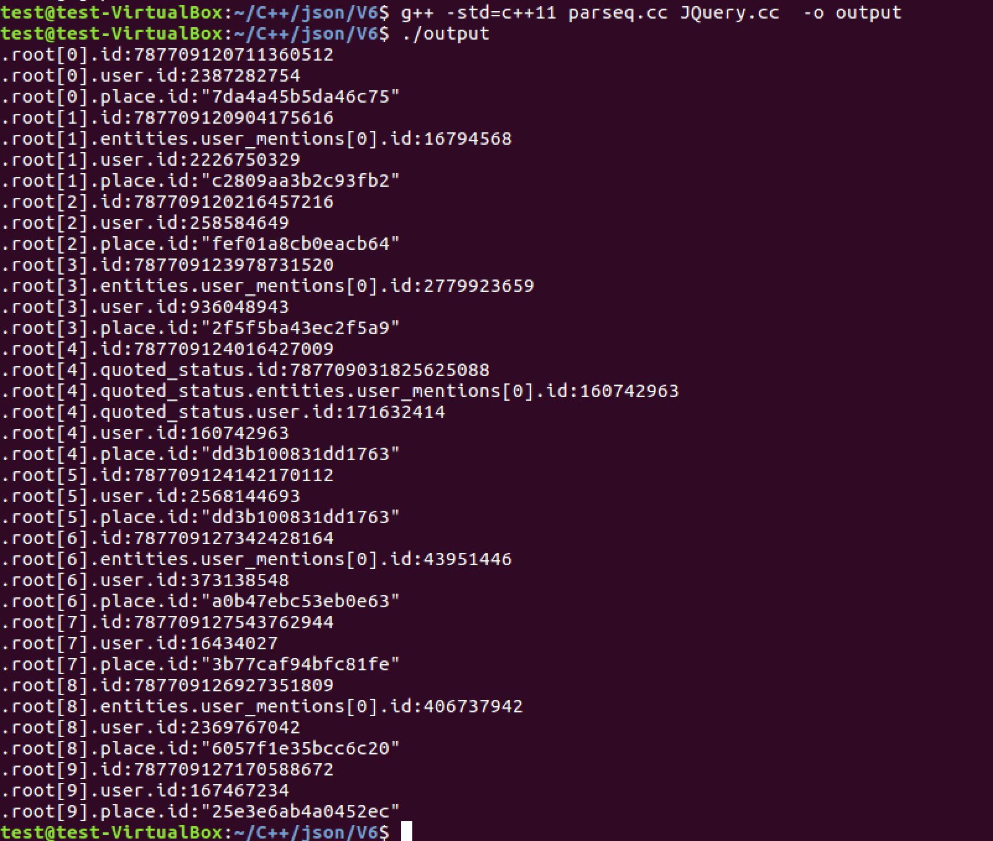

Group 4: Test "bb.json"  
Query 1: $.root.products[*].productId

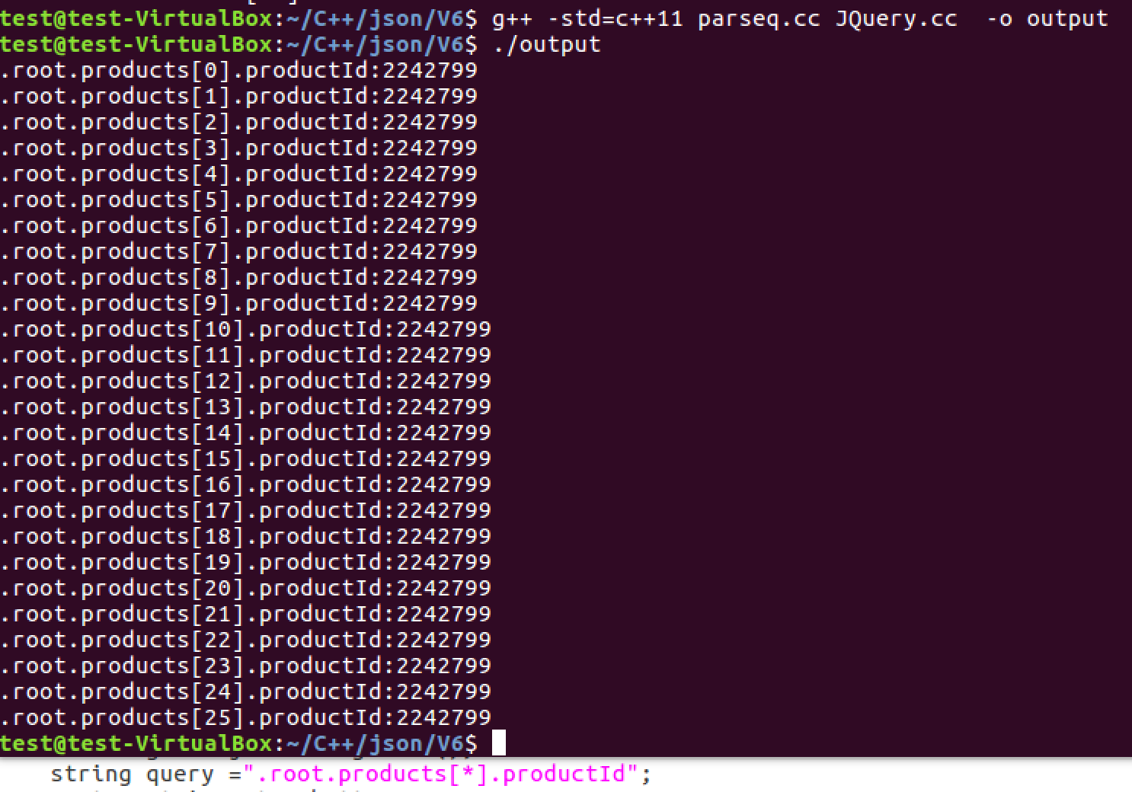

Query 2: $.root.products[2:5].categoryPath[0:1].id

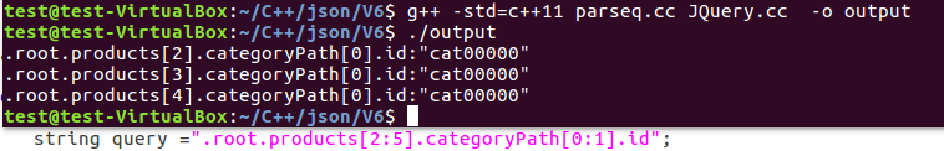

 Query 3: $.root.products[1:6]..serviceLevelId

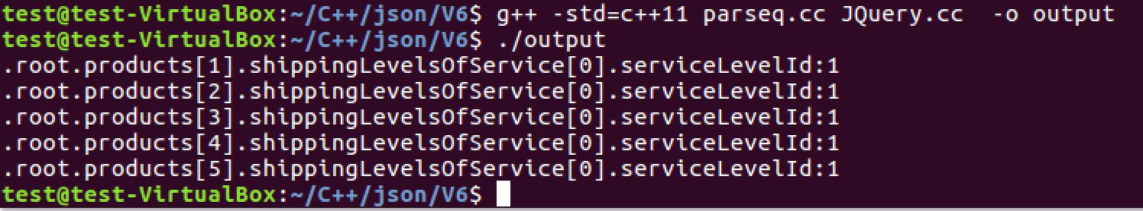

 Query 4: $.root.products[1:6].serviceLevelId



Query 5: $..categoryPath

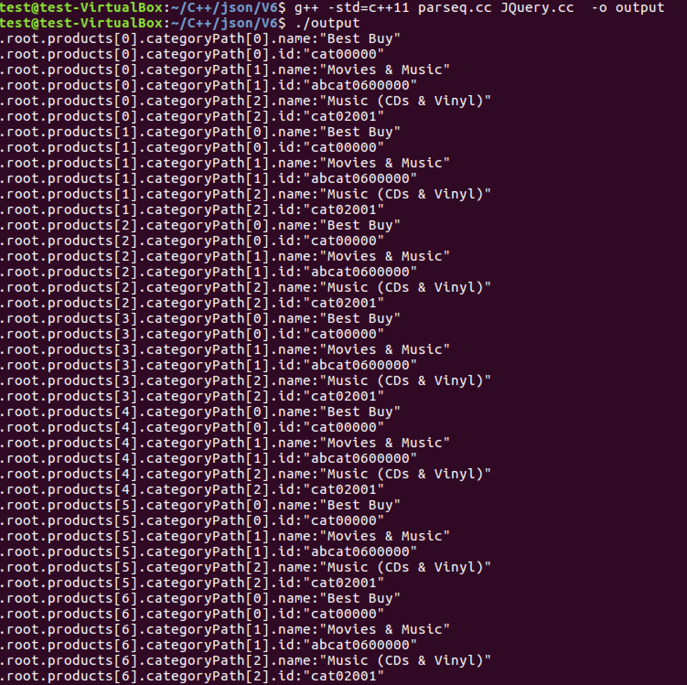

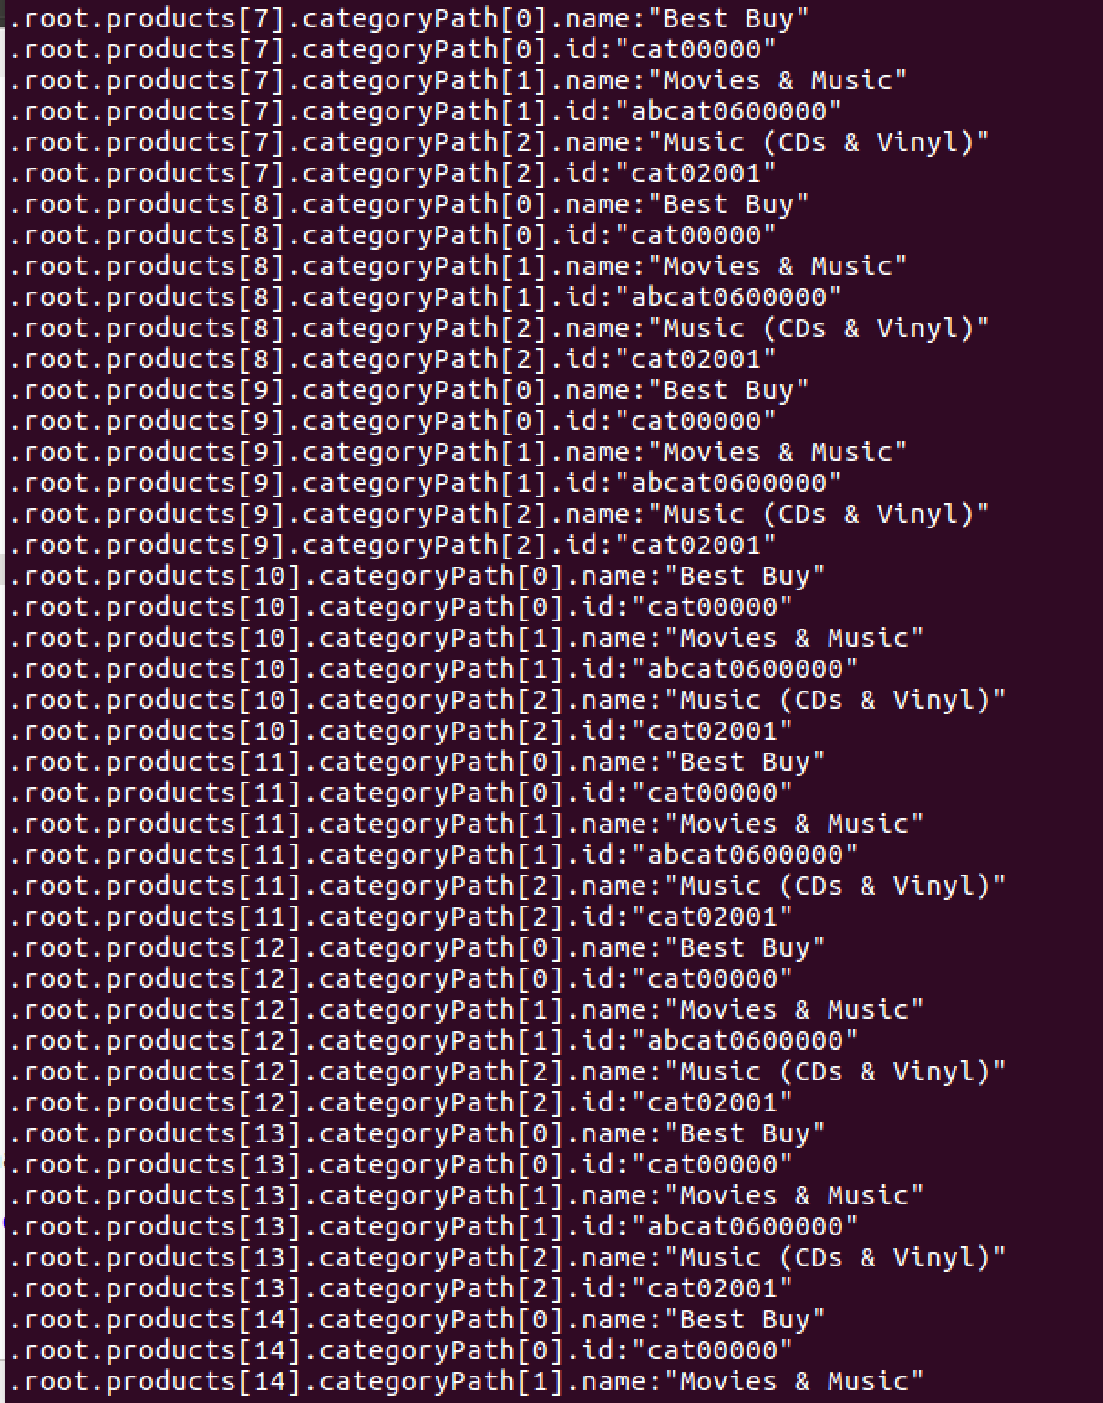

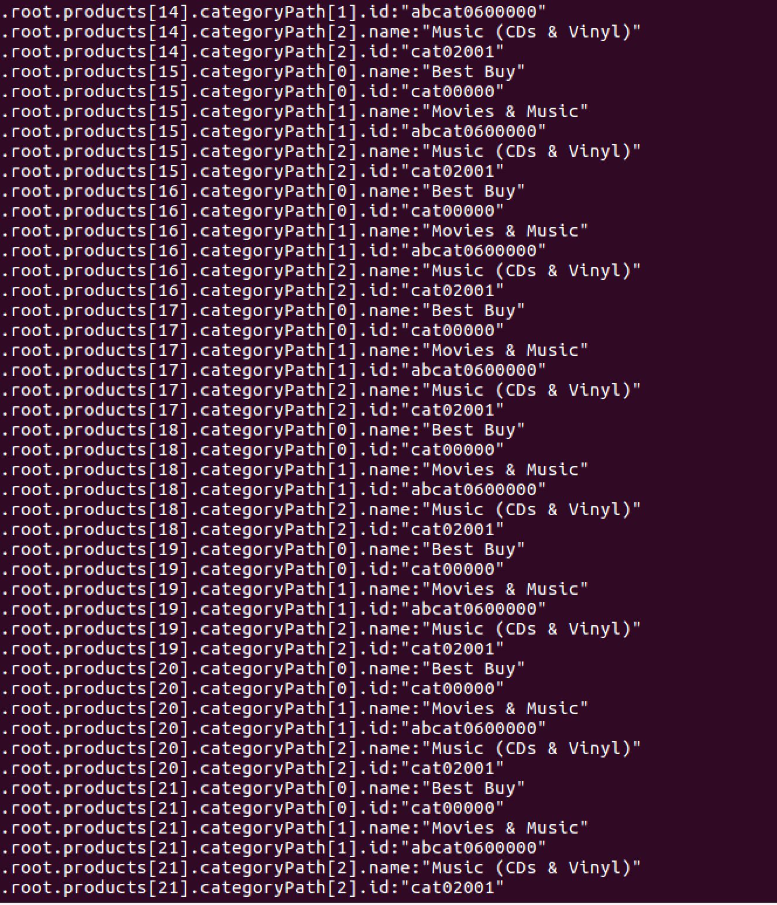

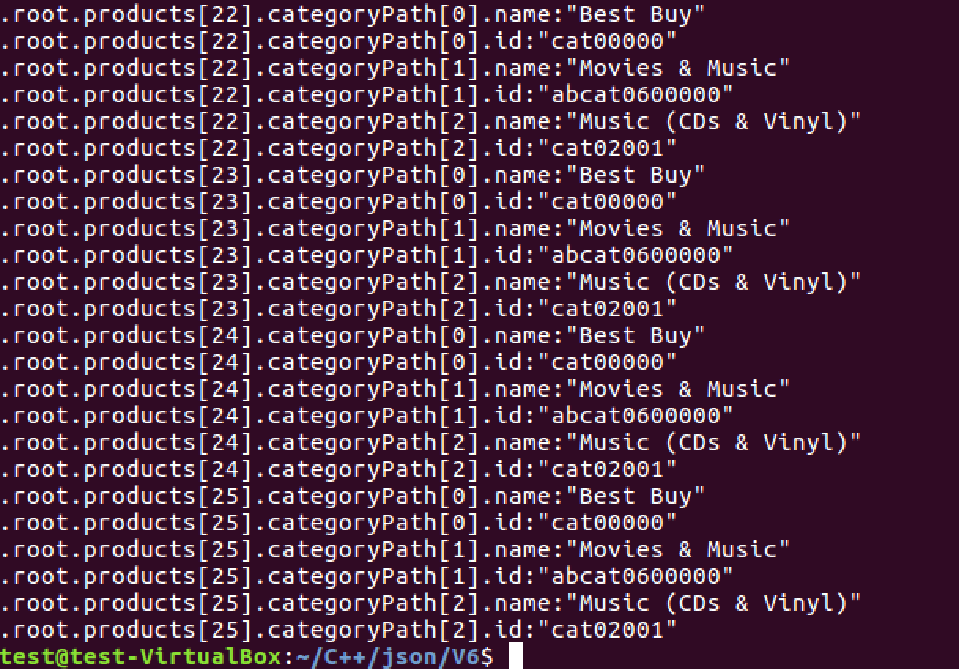

Query 6: $.root..id

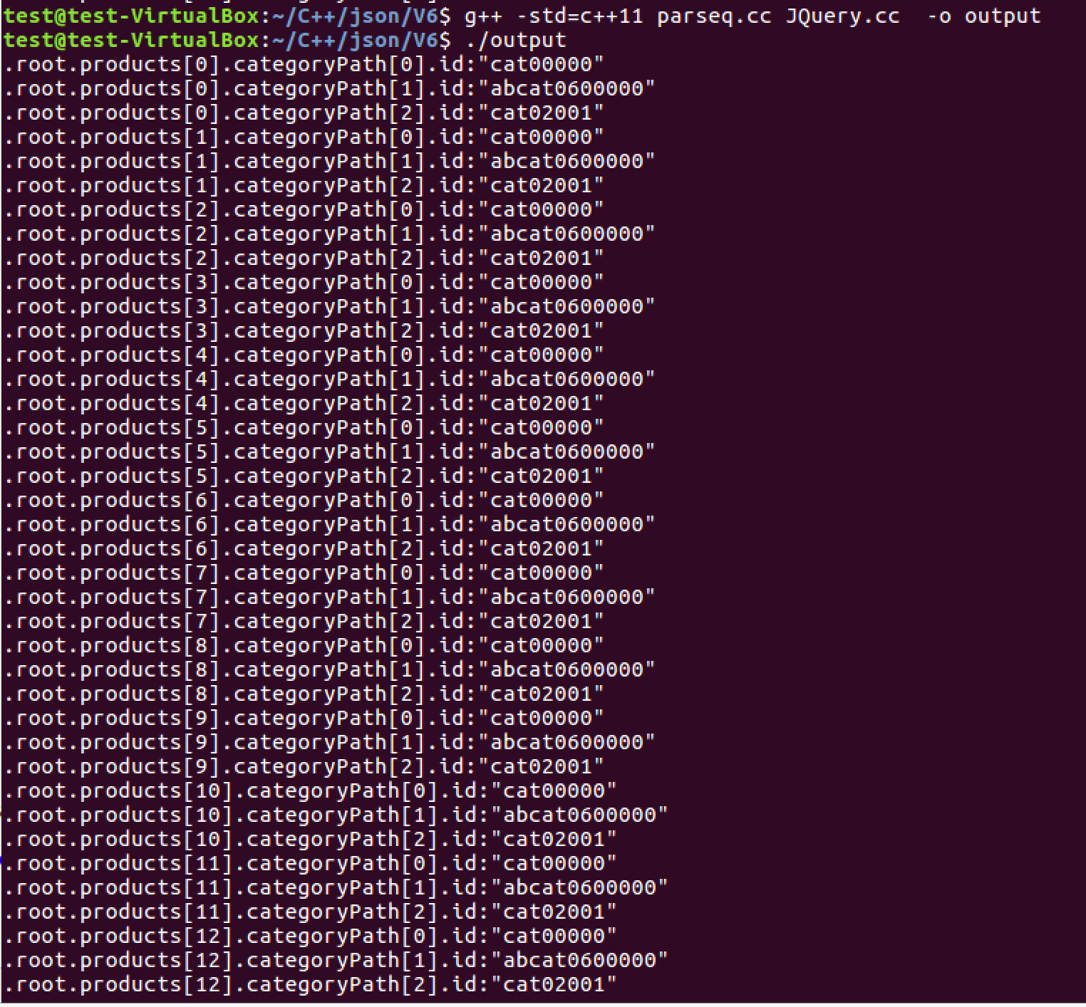

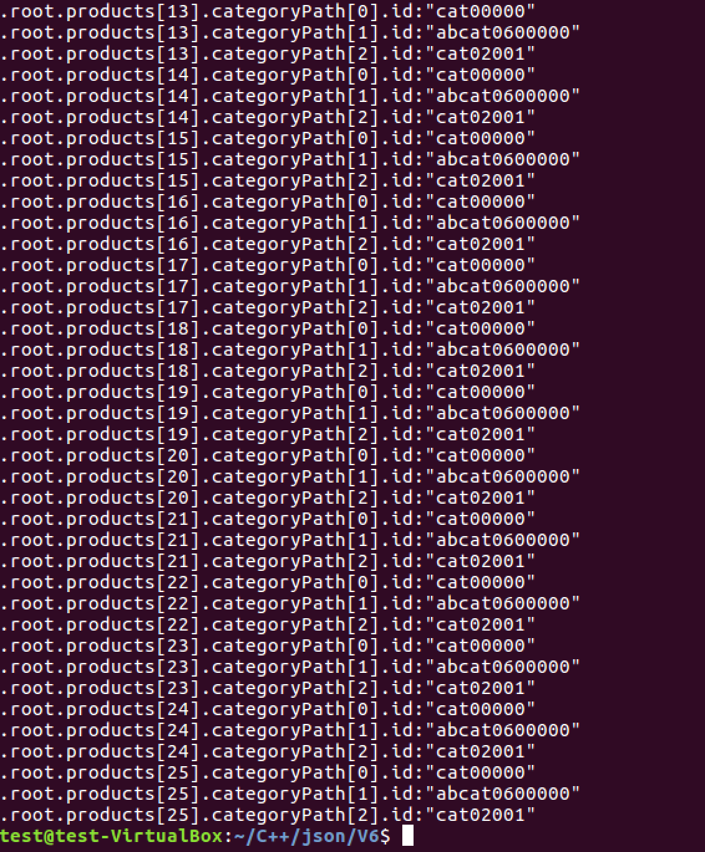

Group 5: Wiki.json

Query 1: $ .root[1].aliases.fr[*].value

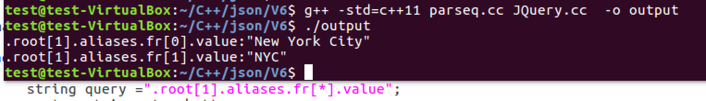

Query 2: $.root..P150..type

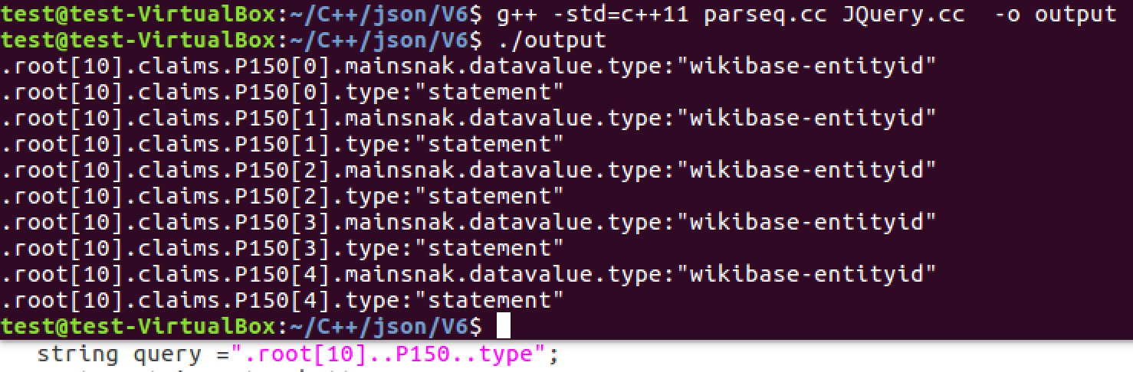

Query 3: $ .root[*]..P625[0].id

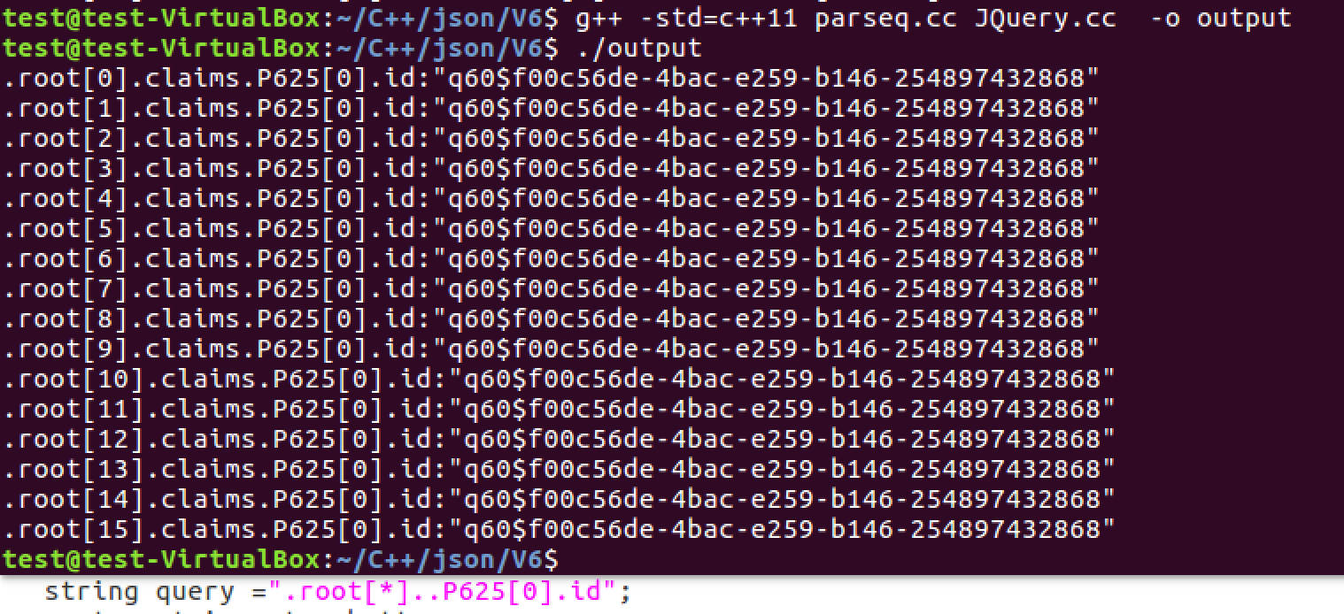

Query 4: $ .root[12:14]..references

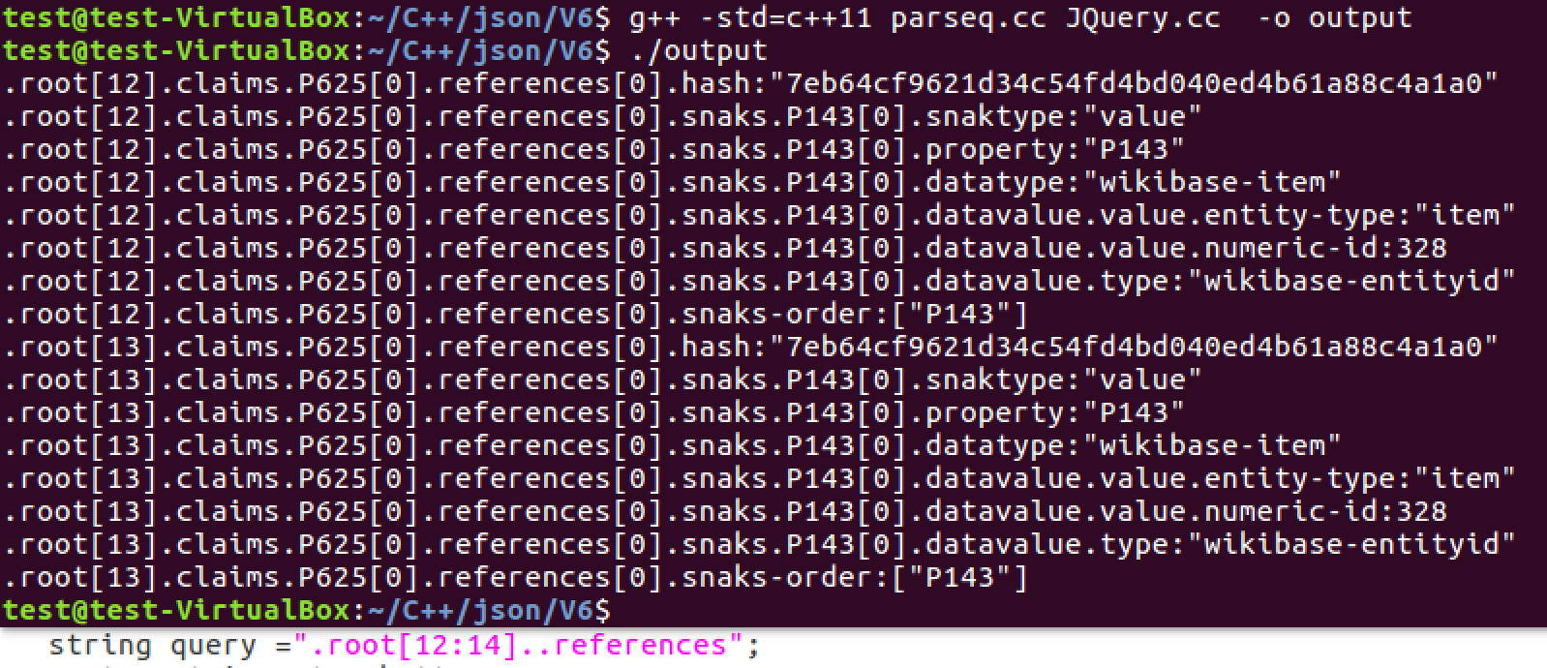

Query 5: $ .root[3:9]..P6[0:4].id

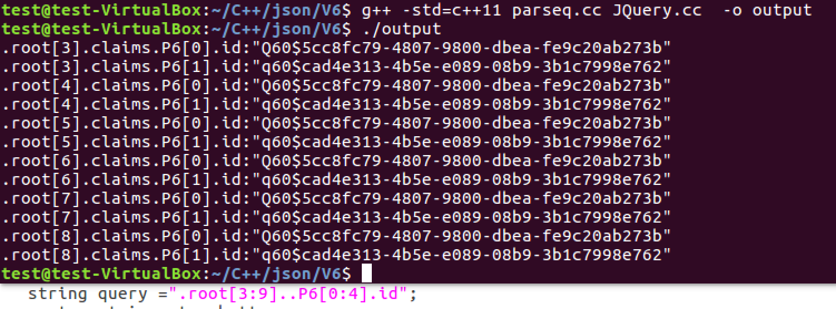

Query 6: $ ..globe

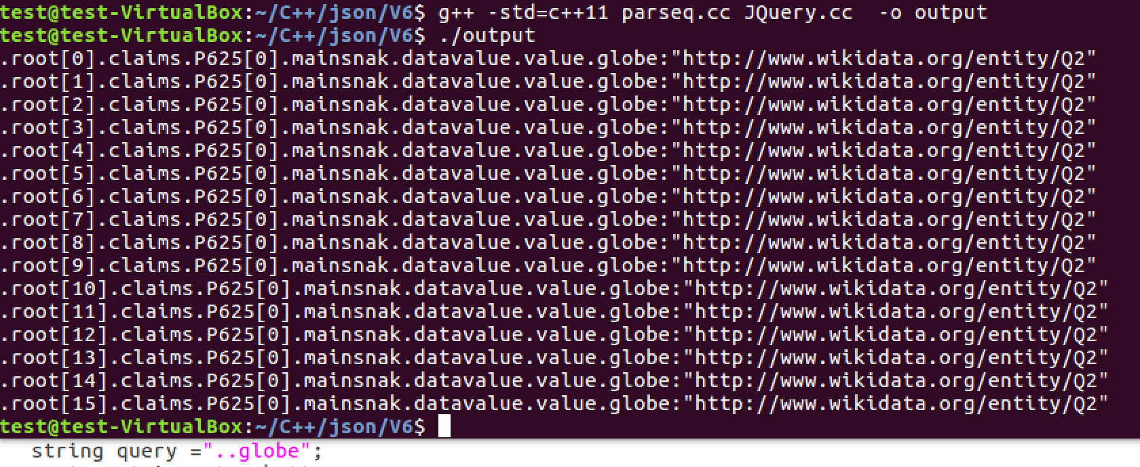

Group5: rowstest.json

Query 1: $ .meta.view.columns[0:3].renderTypeName

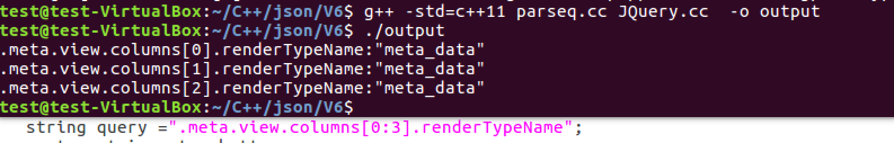

Query 2: $ .meta.view.columns[8:11]..top[5:7].count

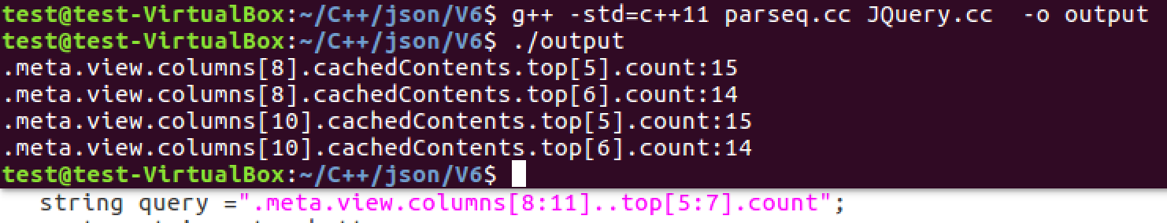

Query 3: $ .meta.view.columns[*].subColumnTypes

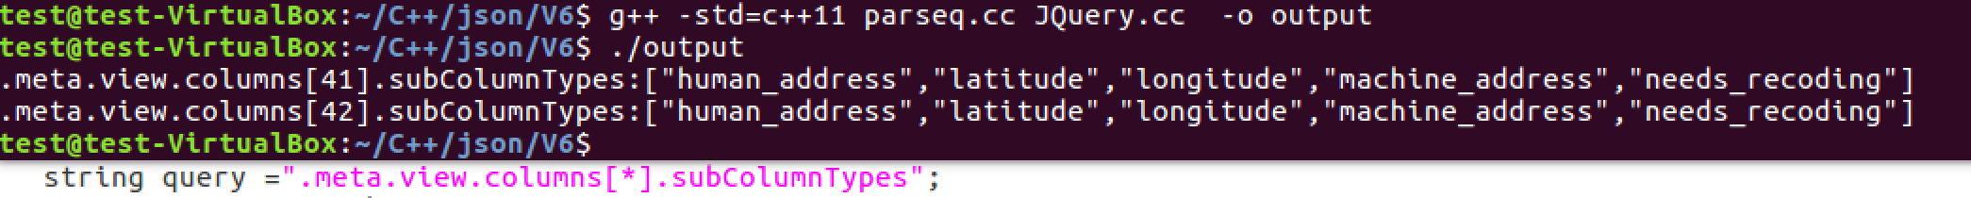

Query 4: $ .meta.view.columns[*].top[19]..count

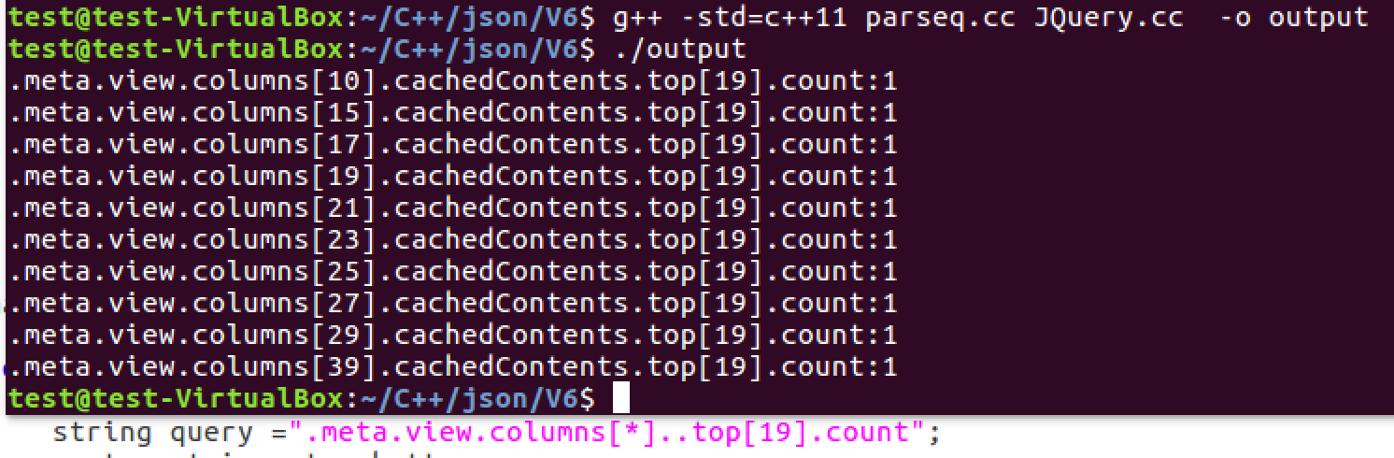

Query 5: $ .meta..grant

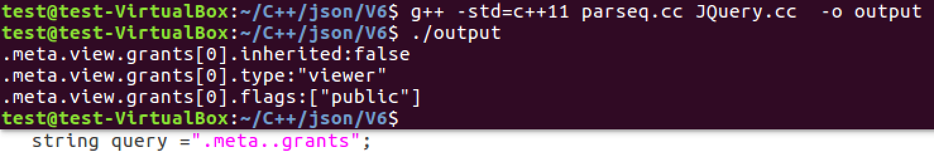

Query 6: $ ..null

